# Report Part 2

### Exercise 1

Some good weather cases we thought of:

* Verifying if methods from mocked classes in method makeGhostSquare are used.
* Test for empty space ( ) in addSquare method.
* Test for wall (#) in addSquare method.
* Test for pellet (.) in addSquare method.
* Test for ghost (G) in addSquare method.
* Test for Pacman (P) in addSquare method.

### Exercise 2

Some bad weather cases we thought of:

* Test if exception is thrown when an invalid char is used in addSquare method.
* Test if exception is thrown when an invalid position is used in addSquare method.
* Test if exception is thrown when an text map is null in parseMap method.
* Test if exception is thrown when an empty ArrayList is used in parseMap method.
* Test if exception is thrown when an only an empty string inside the ArrayList is used in parseMap method.
* Test if exception is thrown when text map lines, which are not of equal width, are used in parseMap method.
* Test if exception is thrown when an empty string filename is used in parseMap method.
* Test if exception is thrown when an inputStream with an empty resource is used in parseMap method.

### Exercise 3

With these test together we have achieved 100% Class coverage , 57% Method coverage, 70% Line coverage

/**  
 * Setting up the mocks for the tests.  
 */  
 @BeforeEach  
 void setup() {  
 pc = mock(PointCalculator.class);  
 player = mock(Player.class);  
 level = mock(Level.class);  
 game = new SinglePlayerGame(player, level, pc);  
 when(level.isAnyPlayerAlive()).thenReturn(true);  
 when(level.remainingPellets()).thenReturn(1);  
 }

/**  
 * Test to see if starting and stopping the game works.  
 */  
 @Test  
 void testStartStop() {  
 assertThat(game.isInProgress()).isFalse();  
 game.start();  
 assertThat(game.isInProgress()).isTrue();  
 verify(level, times(1)).start();  
 game.stop();  
 assertThat(game.isInProgress()).isFalse();  
 }  
  
 /**  
 * Test to see if the game not starts again after already being started.  
 */  
 @Test  
 void testStartAndStartAgain() {  
 assertThat(game.isInProgress()).isFalse();  
 game.start();  
 assertThat(game.isInProgress()).isTrue();  
 verify(level, times(1)).start();  
 game.start();  
 assertThat(game.isInProgress()).isTrue();  
 verify(level, times(1)).start();  
 }  
  
 /**  
 * Test to see if the game isn't in progress if there are no players.  
 */  
 @Test  
 void testStartNoPlayer() {  
 when(level.isAnyPlayerAlive()).thenReturn(false);  
 game.start();  
 assertFalse(game.isInProgress());  
 }  
  
 /**  
 * Test to see if the game isn't in progress if there are no pellets.  
 */  
 @Test  
 void testStartNoPellet() {  
 when(level.remainingPellets()).thenReturn(0);  
 game.start();  
 assertFalse(game.isInProgress());  
 }

### Exercise 4

|  |  |  |  |  |  |  |  |
| --- | --- | --- | --- | --- | --- | --- | --- |
| Collider | Player | Player | Player | Player | Player | Ghost | Ghost |
| Collidee | Empty square | Wall | Pellet | Last pellet | Ghost | Player | Pellet |
| Consequence | Move to square | Nothing | Move to squarePellet disappearPlayer gets points | Move to squarePlayer winsEnd game | Move to squarePlayer diesEnd game | Player diesEnd game | Pellet becomes invisible |

### 

### Exercise 5

See level.PlayerCollisionTestOld

### Exercise 6

See level.CollisionMapTest, level.PlayerCollisionTest and level.DefaultPlayerInteractionTest

### Exercise 7

When comparing the original tests and the tests we wrote, we can see for the collisions of the game, that the original tests only covered the PlayerCollisions class and not the CollisionInteractionMap and DefaultPlayerInteractionMap. From the PlayerCollisions class not every method is covered completely. From the method "collide" the third if statement isn't covered. Also the method pelletColliding isn't covered.

The tests we wrote ourselves cover the DefaultPlayerInteractionMap and the CollisionInteractionMap almost completely (except for the method collide in the case the collisionHandler is null and getInheritance method for the if statement in the for-loop). Compared to the original tests, our tests cover all lines from the PlayerCollision class.

### Exercise 8

One way to test the method is by observing it's behavior manually. If we execute the random method a thousand times and only the directions East, West and South are returned we can conclude that the random method is probably not well configured, This type of testing is very unreliable of course. A better approach to this problem would be using seeds for the random method. With this seed the random method will always return the same value. By using different seeds we can cover all decisions.

### Exercise 9

The source of the flakiness is found in the Thread.sleep() line. This sleep is used to let the ghosts move around the board. However the movement of the ghost are not consistent and might therefore give different results with every test. As soon as a test relies on any form of randomness the test can be flagged as flaky. Writing big test may often result into flaky tests, as can be seen here. A simple solution would be by splitting the test and testing eaten-by-ghost separately. Using mocks to simulate necessary behavior is also a good solution against flaky tests.

### Exercise 10

The biggest disadvantage is that 100% code coverage creates this illusion that everything has been tested and is therefore bug-free. But this is NOT the case. Even though every piece of code is covered, bugs might still be present. Code coverage should be used as a tool to indicate how much someone has not tested the software, rather than estimating how much testing has been done already.

### Exercise 11

* The main disadvantage of mocking is that is that test can become very slow if there are many mocks involved.
* Since mocks are a reflection of the actual implementation it can slow down the testing process significantly.
* Mocking makes the setup of test very complicated (, much more complicated than test without mocks).

### Exercise 12

Test tend to decrease in execution time when they grow bigger and/or when multiple mocks are used. To avoid slow test or to speed them up, a good place to start is to break up big tests into smaller ones. Three/four asserts at most per test. If your test requires multiple mocks you should consider making your class less coupled.

### Exercise 13

Mocking should be used whenever we need a dependency or something equivalent. However, mocking should be avoided if your class is too coupled

### Exercise 14

When running the AmazingPointCalculator instead of the DefaultPointCalculator, it seems like the following four anomalies occur: * After eating around 28 pellets or more, the PointCalculator deducts 15 points after each pellet. * The score counter seems to suddenly change to an enormous negative number, possibly due to an overflow, after eating around 15 pellets or more and facing West. * After eating more than 34 pellets and facing North direction the game stops, and you get a Runtime exception * After eating more than 34 pellets Pacman suddenly dies, without any of the ghosts killing it.

### Exercise 15

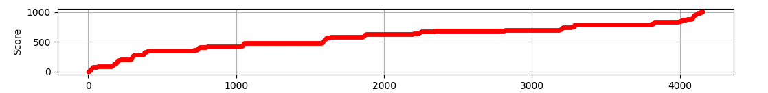

**normal**

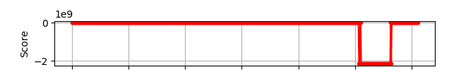

abnormal

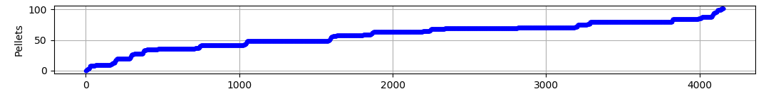

**normal**

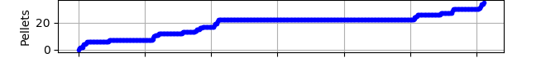

abnormal

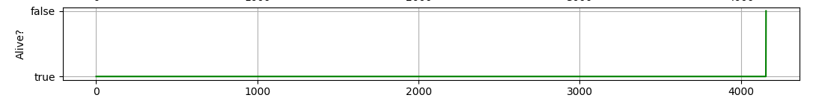

**normal**

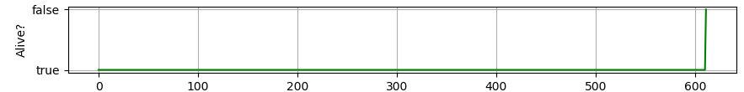

abnormal

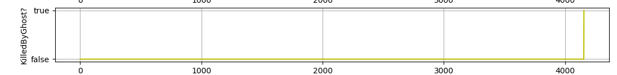

**normal**

normal

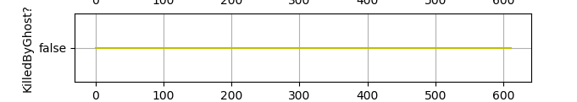

abnormal

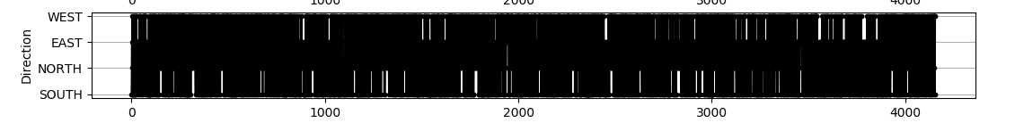

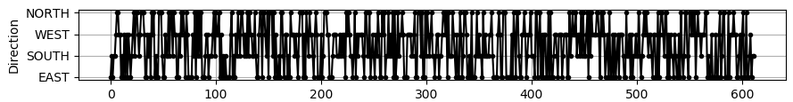

**normal**

abnormal

**Anomaly 1:**

*The score counter seems to suddenly change to an enormous negative number, possibly due to an overflow, after eating around 15 pellets or more and facing West.*

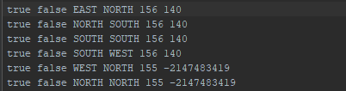

From the generated logs we can see that after 140 points (around 14 pellets), there occurs an anomaly namely the sudden change to an enormous negative number. This didn’t affect the current number of pellets at that time, if the player is alive or if the player has collided. The only two things that could have affected it were the current points and the direction. Since the current points stayed the same for a while, it probably had to do with the direction. In this case going from West to West. Since earlier in the logs the player already did the same movement to the West direction, the anomaly probably occurs after a certain amount of pellets have been eaten and the direction changes from West to West.

**Anomaly 2:**

*After eating around 28 pellets or more, the PointCalculator deducts 15 points after each pellet.*

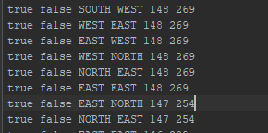

*As can be seen from the log the log around the 269 points (~27 pellet) the points have been increasing. But when the 28th pellet has been eaten the points suddenly decrease by 15.*

**Anomaly 3:**

*After eating more than 34 pellets and facing North direction the game stops, and you get a Runtime exception*

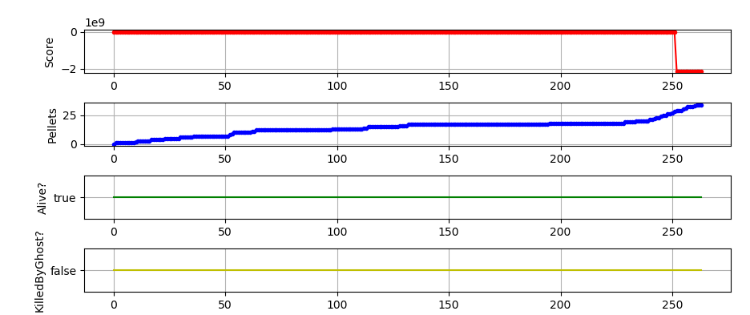

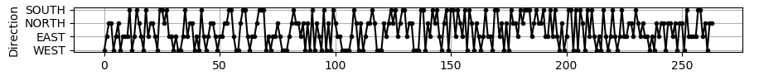

*(this is another graph from the abnormal behavior)*. So the only difference is the amount of pellets, the score and the direction.



Since the total amount of pellets is 178, this log shows the game ended after the 34th pellet (*178-144 = 34).* The score roughly corresponds to the change in pellets so we can ignore that here.We can also see that the direction changed from North to North so this means that the exception occurred after more than 34 pellets have been eaten and the player moved North.

**Anomaly 4:**

*After eating more than 34 pellets Pacman suddenly dies, without any of the ghosts killing it.*

From the graphs created out of the generated logs *(not the ones from anomaly 3*), we can already see that the player with the abnormal behavior is almost never killed by the ghosts.

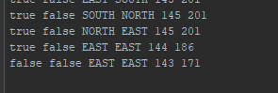

However the status from the player is set to False. We can further see that the amount of pellets and the score have changed while the direction stayed the same with one iteration before. Since the player Alive status has been set to false at around 143 pellets left this means that around the 35th pellet the player has been killed without any of the ghost having collided with the player. So this means that if pacman eats more than 34 pellets, and not faces north direction afterward *(no runtime exception so we must exclude the case for anomaly 3 since that one is almost the same),* he dies.

### Exercise 16

### 

The staticAnalysis tool indicates that the build has been successful without any warnings. The reason that AmazingPointCalculator doesn't trigger any PMD warnings is because the class executes an abnormal behavior that has code implemented similiar to other methods in the project. So PMD couldn't tell the difference from the way the code has been structured and therefore couldn't tell apart that this class will execute some abnormal behavior. Looking at the OWASP top 10 vulnerability list, we can say that this 'Using Components with Known Vulnerabilities'. This is because we replaced our PointCalculator component (DefaultPointCalculator) with that of a third party one into our application. Since we are unsure if the component works as it should do, because we got te component from a third party, their is a chance that this component has a vulnerability. To solve the vulnerability we should always check if we receive components from a trusted source and if the component is up to date. We should also check if the component works as expected.

### Exercise 17

Dynamically loaded classes enables the developer to install software components at runtime. This means that classes are loaded on demand and at the last moment possible. The security problem that comes with this, is that third-party can use the component for malicious use, so the developer should check if the components comes from a trusted source. The developer should also create his own dynamically loaded classes and, in order to achieve isolation from dynamically loaded component, the developer should also separate it with by using different class loaders.

### Assesment

In general, we committed once per exercise. Sometimes multiple commits were needed because a small discussion changed our final answer. CI sometimes failed because we didn't always execute Gradle check. So this also resulted into multiple commits per exercise.